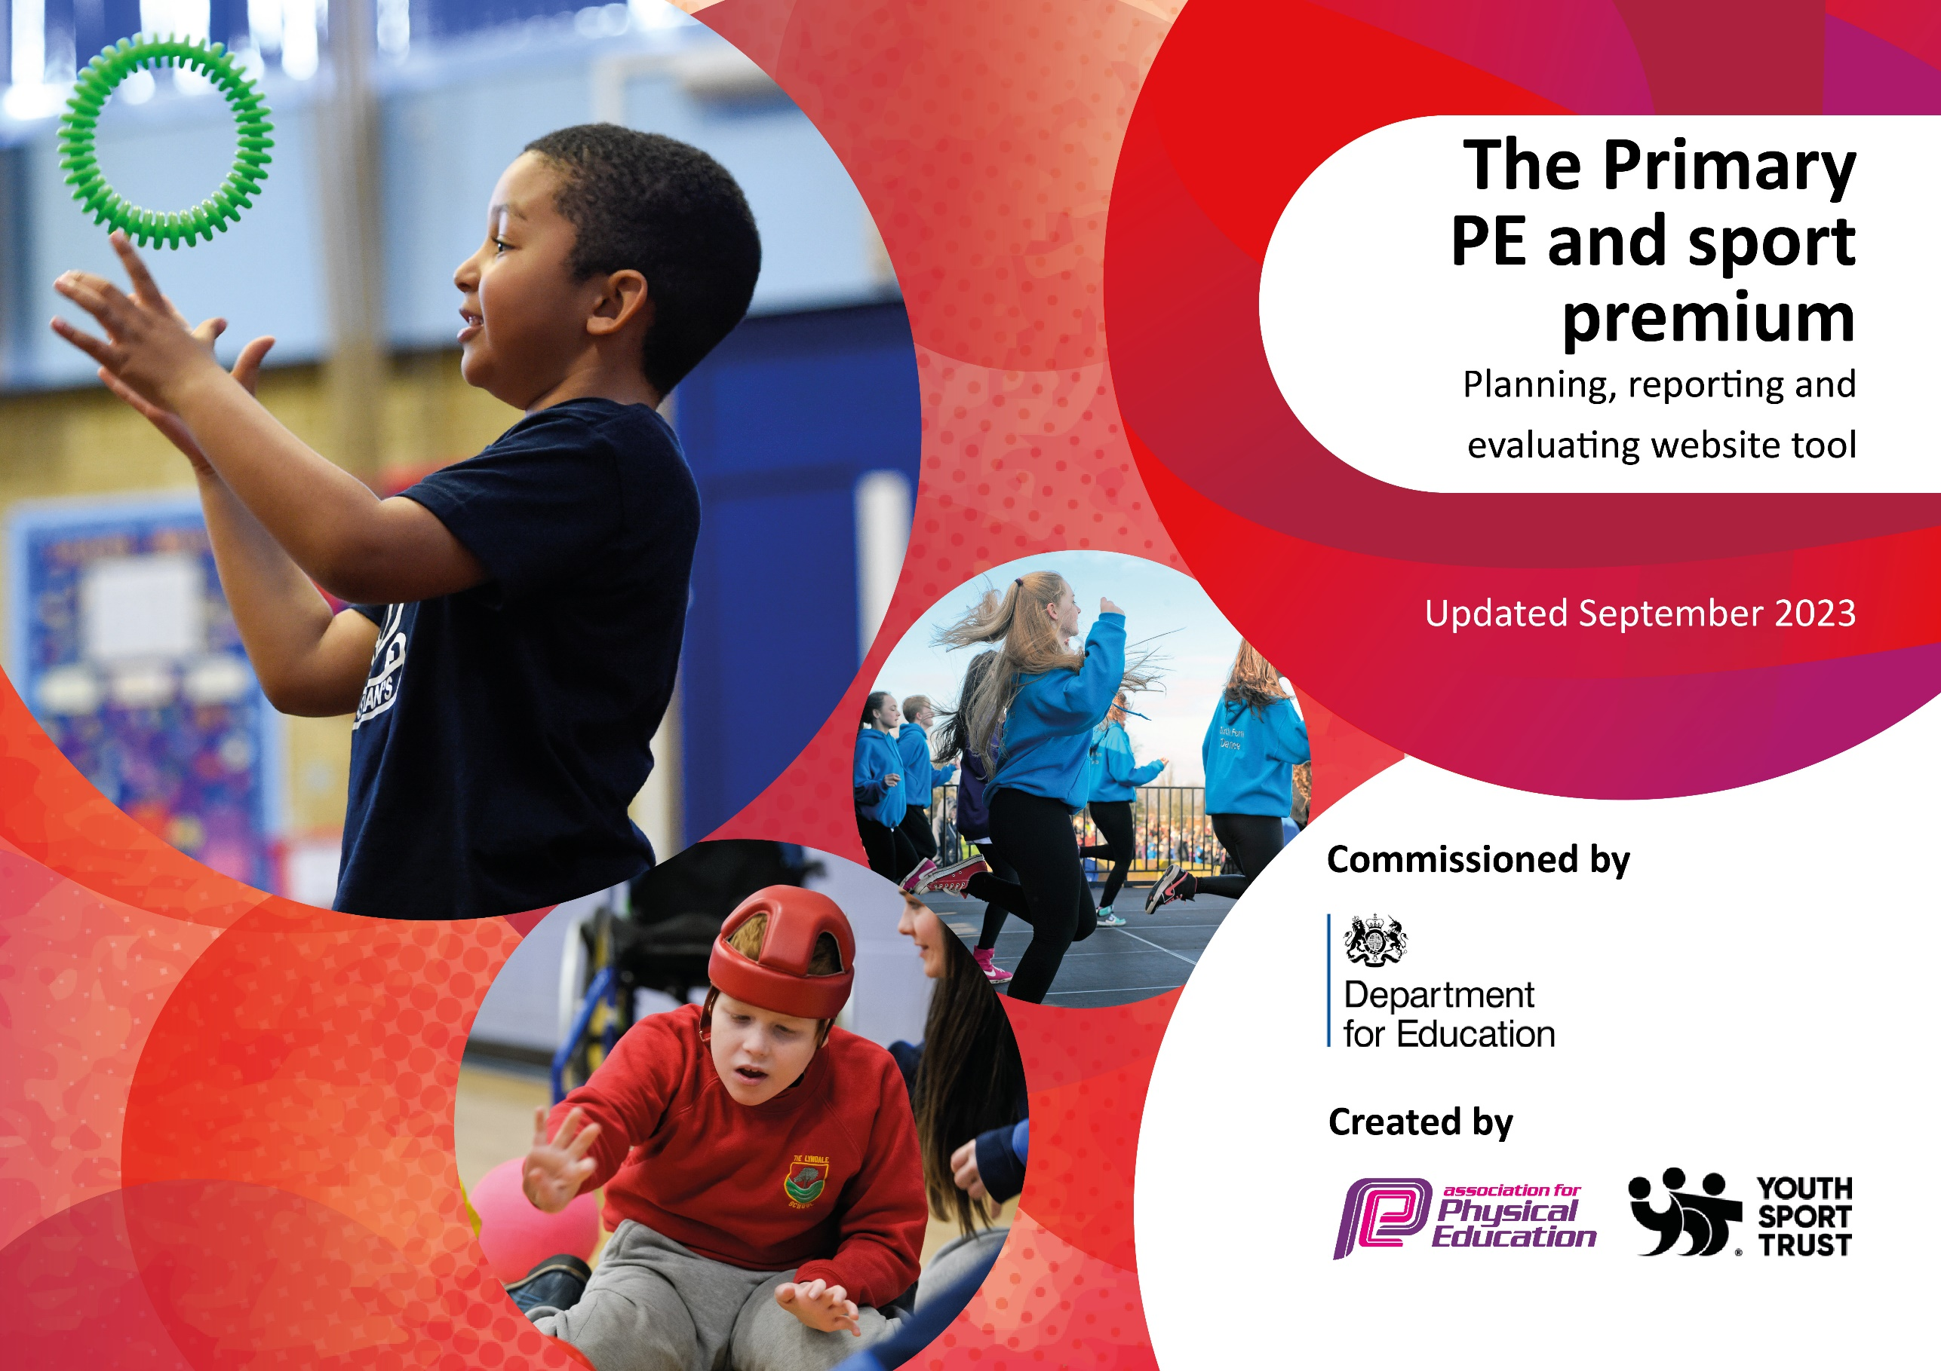

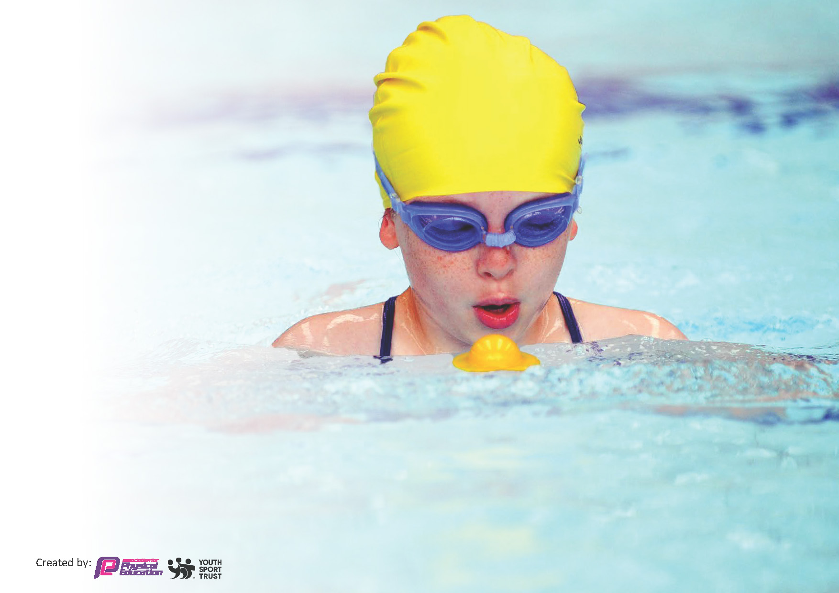
This template can be used for multiple purposes:
by:
- It enables schools to effectively plan their use of the Primary PE and sport premium
- It helps schools to meet the requirements (as set out in guidance) to publish information on their Primary PE and sport premium
- It will be an effective document to support Ofsted inspections enabling schools to evidence progress in Physical Education (PE) and evidence swimming attainment, which forms part of the PE National Curriculum. We would recommend schools consider
the Intent, Implementation and Impact of any spend, as examined within the Education Inspection Framework.

It is important that your grant is used effectively and based on school need.

Schools must use the funding to make additional and sustainable
improvements to the quality of the PE, School Sport and Physical Activity (PESSPA)
they offer. This means that you should use the Primary PE and sport premium to:

- Build capacity and capability within the school to ensure that improvements made now will benefit pupils joining the school in future years
- Develop or add to the PESSPA activities that your school already offers.

The Primary PE and sport premium should not be used to fund capital spend projects; the school’s core budget should fund these. Further detail on capital expenditure can be found in the updated Primary PE and sport premium guidance.

The Primary PE and sport premium guidance, outlines 5 key priorities that funding should be used towards. It is not

necessary that spending has to meet all the key priorities, you should select the priorities that you aim to use any funding towards.

Although completing this template is not a requirement for schools, schools are required to publish details of how they spend this funding. Schools must also outline what the impact this funding has had on pupils’ PE and sport participation and attainment and how any spending will be sustainable in the future. All funding must be spent by 31st July 2024.

The Department for Education has worked closely with the Association for Physical Education (afPE) and the Youth Sport Trust (YST) to develop this template and encourages schools to use it. This template is an effective way of meeting the reporting requirements of the Primary PE and sport premium.
Review of last year’s spend and key achievements (2022/2023)

We recommend you start by reflecting on the impact of current provision and reviewing your previous spend.

Activity/Action | Impact | Comments
Access to lunch time play sports provision  CAFC coaches delivering lunch time physical activity games | Children had access to organised and safe physical activity which was age appropriate and promoted physical activity at Chatsworth | CAFC re-booked with the intention of training Burnt Oak sports leaders to assist and create a program for sports leaders.
Playground equipment to encourage physical activity during the breaks. | Playground equipment to promote physical activity during break times.  New and age appropriate equipment for extracurricular sports clubs | Children had better experiences of extra curricular sports clubs – clubs led by PE teachers were also free to pupils.
Support staff through relevant CPD training | Staff were upskilled in the teaching of dance and gymnastics. Staff also had access to a PE software which supports their planning and assessment. In turn this enabled children to have access to higher quality PE teaching. | Continue the subscription with the PE Pro and continue to implement CPD courses for schools to ensure P.E continues to have teachers with good subject knowledge and confidence
Enabling more areas of the playground are accessible for P.E and extra-curricular sports clubs | Children have access to safer flooring suitable to P.E. and at play times can use an all weather facility for physical activity. | Excellent investment and will be used for years to come.

Key priorities and Planning
This planning template will allow schools to accurately plan their spending.

Action – what are you planning to do | Who does this action impact? | Key indicator to meet | Impacts and how sustainability will be achieved? | Cost linked to the action
Lunchtime sport sessions/activities for pupils. | Lunchtime supervisors / teaching staff, coaches - as they need to lead the activity  pupils – as they will take part. | Key indicator 2 and 4 | More pupils meeting their daily physical activity goal, more pupils encouraged to take part in PE and Sport Activities. | £4140
Age appropriate sports equipment for extracurricular clubs | Pupils – access to better equipment  Teachers – better resources to deliver more clubs | Key indicator 4 | Age appropriate equipment for sports clubs and enable more clubs to run throughout the year. | £2239 costs for equipment
AfPE membership | Teachers | Key indicator 1 | Membership to AfPE allows access to all regular updates to P.E, Health and safety policies. | £95
Sports workshops | Children | Key indicator 2 and 4 | Children access internal sports workshops and have greater experiences with sport | £275 tennis workshop  £295 OAA workshop

Entry to sports festivals and competitions | Children | Key indicator 5 | Increase competitive sport opportunities and the number of children attending them | £64 CAFC competition  £32 cricket competition  £50 TPA football
Raising the profile of PE – certificates and medals for sports day | Children | Key indicator 3 | Raise the profile and introduce more reward systems in place for children to achieve in PE and at sports day | £28 certificates  £179 sports day medals
Investment in sports facilities and grounds | Children | Key indicator 2 and 3 | Ensure the astro is maintained to allow multi-weather PE lessons and extra-curricular clubs to run all year round  Sports markings for football during autumn and spring. Athletics markings for Summer | £553 all sports marking  £500 maintenance and health and safety checks of astro
Supply cover to attend sports festivals and competitions | Children | Key indicator 1 and 5 | Ensure PE lessons still run in the curriculum to allow children to attend sporting experiences and CPD opportunities | £1800
Hire of transport to attend sporting competitions and festivals | Children | Key indicator 5 | Children are able to attend sporting experiences and having access to attend them | £2500
CPD for non-specialist PE teachers | Staff | Key indicator 1 | CPD opportunites for staff. PE Pro CPD and all staff PE teaching workshop, tennis curriculum CPD coaching, dance curriculum CPD | £3828
CPD for specialist PE teacher | Staff | Key indicator 1 | Bexley CPD: Physical Literacy in EYFS and KS1  Sport Literacy: Games based v skill-based teaching in KS1 | £555

Key achievements 2023-2024
This template will be completed at the end of the academic year and will showcase the key achievements schools have made with their Primary PE and sport premium spending.

Activity/Action | Impact | Comments
Lunchtime sport sessions/activities for pupils. | Children have access to sports coaching at lunch time which is organised by an external coach | 30 minutes of physical activity opportunities and behavior improvement in sport
Age appropriate sports equipment for extracurricular clubs | More sports clubs running  More lunch time sports equipment  More engagement in sports club
Sports workshops | Children experiencing additional sports opportunities on top of the PE curriculum | Broader range of sporting opportunities available
CPD | Class teachers confidence in teaching PE is a lot more confident and competent | PE specialists philosophy embedded and evidenced through attending CPDs
Sports competitions | More children attending sports competitions | Tennis x 8 children  Boys football x 16 children  Girls football x 14 children  Cricket competition x 10 children

Signed off by:

Head Teacher: | Ian McManus
Subject Leader or the individual responsible for the Primary PE and sport premium: | Luke Kimberley – Head of P.E
Governor: | Lou Lynch
Date: | 22/7/24

